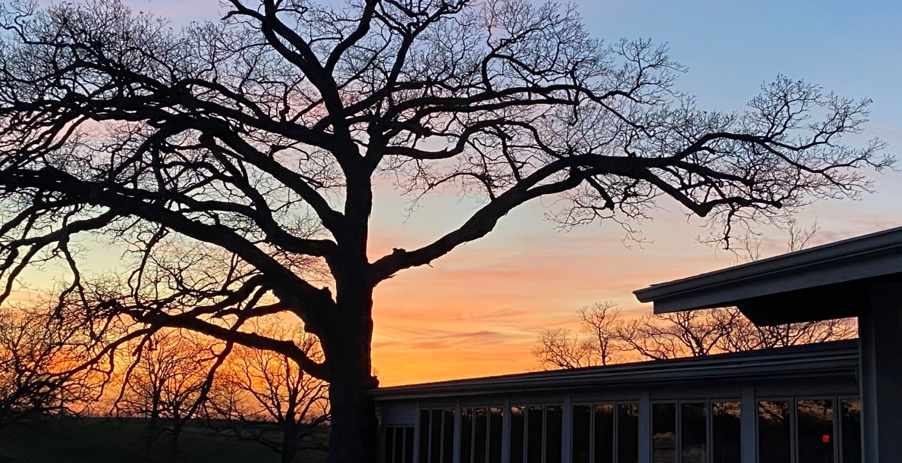
May 2023 – EPGC InFOREmer
UPCOMING EVENTS:
May 5, Fri Cinco de Mayo Celebration All Day
May 14, Sun Mother’s Day Brunch 10a to 2p
May 17, Wed EPGC Board Meeting 6:00p
May 18, Thur Member Steak Fry 5p to 8p
May 29, Mon Memorial Day – Breakfast Served 6 – 11a

RESTAURANT/BAR:

BAR LUNCH DINNER BREAKFAST
Mon: 9:30a-9p 11 – 5p (Limited Menu)
Tue: 9:30a-9p 11 – 5p 5 – 8:30
Wed: 9:30a-9p 11 – 5p 5 – 8:30
Thur: 9:30a-9p 11 – 5p 5 – 8:30
Fri: 9:30a-Cl 11 – 5p 5 – 8:30
Sat: 6a - Cl 11 – 5p 5 – 8:30 6a – 11a
Sun: 6a – 7p 11 – 5p Closed 6a – 11a

Please call 309-739-2013 for Reservations or to place a Carryout order

EPGC Bar will remain open for guests beyond posted close times when appropriate.
CINCO DE MAYO CELEBRATION – Friday, May 5 – All Day

Join us this Friday, May 5 as we celebrate Cinco de Mayo with drink specials all day featuring $4 Margaritas, $3 Corona & Dos Equis Bottles, and a Taco/Nacho Bar starting at 5:00. The Ladies Preseason Shotgun Scramble kicks off the day at Noon.

Special thanks to El Bandido Tequilla for their support!

MOTHER’S DAY BRUNCH – Sunday, May 14 – 10a to 2pm

Make your reservations now for this year’s brunch celebrating all of the great EPGC Mothers! Menu will feature a delicious variety of favorite brunch dishes, carving station, full salad bar, desserts, and more! We will be having three separate seatings to choose from; seating is limited for each and Reservations are required. Watch for the full menu in an upcoming email.

Choose from the 10a, 11:30a, or 1p seating.
Adults: $21.95 Kids (4-12): $10.95 3 & Under: Free

MEMBER STEAK FRY – Thursday, May 18 – 5-8pm

Watch for more details coming soon on this popular dinner night at the Club!

CLUB NEWS:

EPGC’s 100th ANNIVERSARY

Proudly El Paso Golf Club prepares to celebrate its 100th year of operation in 2024. The board is requesting that anyone interested in serving on the 100th Year Anniversary Committee express their interest to Rick or Laura in the club office (309-739-2103 ext 2)

Thanks,

EPGC Board

New Course Superintendent Hire…

Dear EPGC Members,

I am very pleased to announce that EPGC has hired a very experienced Grounds Superintendent with vast technical experience in golf course turf maintenance and equipment expertise. He started with EPGC on May 2nd.

His name is Gene Weiser and he has relocated from Iowa to the El Paso area. He is coming to EPGC from Pleasant Valley Golf Course in Iowa City, Iowa where he has been Superintendent since 2021. This golf course has over 35,000 rounds of golf per year and weekly tournaments and outings.

Gene brings a hands-on approach in managing employees and golf course maintenance, including equipment. As Superintendent of Pleasant Valley, he was also the equipment mechanic! He is passionate about self-improvement by taking advantage of many golf association training tools and programs and proactively brings these training opportunities to his team members.

Some of Gene’s other golf course experience include being Superintendent at Washington Golf & Country Club in Washington, IA, Superintendent of Lake of the Woods GC in Locust Grove, VA, Superintendent of Gibson Island GC in MD and Assistant Superintendent at Reems Creek GC in NC.

Golf maintenance is actually Gene’s 2nd career, as he previously proudly served his country for 26 years as a Marine. Gene is a decorated combat Marine who served from 1980 to 2006. His rank upon retiring was Senior Battalion Sergeant Major as a Combat Unit Leader.

After serving his country, Gene needed a new mission in life, which turned out to be Turf Management. He immersed himself in his new field and earned a Bachelor of Science degree in Turf Management and then a Master’s degree in Plant Physiology. He has been an active member of GCSAA (Golf Course Superintendents Association of America) since 2014.

Please join me in welcoming Gene Weiser as our new Superintendent!

Rick Robbins
General Manager

May Golf Events
Saturday, April 29th & Sunday, April 30th: Member Weekend Permanent tee times begins
Monday, May 1: Men’s League begins, 5:00pm,
Tuesday, May 2: Ladies Day begins
Wednesday, May 3: Couples League begins, 9:00am
Thursday, May 4: Men’s Play Day begins
Friday, May 5: 4 Person Ladies Invite, 12:00 shotgun
Monday, May 8: Shriner’s Club, 12:00 shotgun
Monday, May 15: Sandtrappers, 9:00am shotgun, 100 golfers
Friday, May 19: BPD, 11:00 shotgun
Saturday, May 20: 2 Person Qualifying Begins
Sunday, May 21: Wedge Clinic
Monday May 23: CIFTA, 11:00am shotgun, 100 golfers, tee closed 7:30—4:00
Monday, May 29: Memorial Day, NO PERMANENT TEE TIMES
-Members & their guests only on the 29th. Call to make tee times.

Two Person Best Position QUALIFYING
Friday, May 20 thru Sunday, June 4, 2022
Entry Fee: $20.00 per team (payable the day you qualify)
June 5 – June 18 > 1st round
June 19 – July 8 > 2nd round
Sunday, July 9> Finals – Times 12:56 – 2:00
Please give your opponents plenty of options to play matches, not just one day.
Both flight finalists be available to play on Sunday, July 9
Golf Staff is changing again. There are some new employees at the club this year. Please introduce yourself to our new employees and make them feel welcome. When you come to the golf course to play, please check in with the golf shop staff. If you don’t check in, they won’t be able to get to know you. We try to keep an accurate tee sheet each day so if everyone checks in before they go out to play this helps us out a lot. Thank you for your cooperation.
May Wedge Clinic
May 21st
5:30 pm – 7:00 pm
Cost: $180
We will have a clinic hosted by Matt Schuerman. This is a relaxed atmosphere that will start at the bar and work our way down to the pitching green.
The clinic will start with chipping and work out to 50 yards. We will be discussing how to hit wedges, lofts and bounces on the clubs and any other thoughts that participants may have.
At the end of the clinic everyone will receive a new wedge.
Check out this old article by GolfWRX

Groove Test: How often should you change wedges?
Spots are limited so please sign up in the golf shop.

Spring Cleaning Sale
Starts May 1st
Ends May 14th

It is time to clean out your closets.

Bring old golf polos to the golf shop and you will receive 1% off for every shirt you donate off your purchase of new apparel.
Max 20% off your purchase by bringing in 20 old polos, or more.
Any golf attire qualifies. Please clean clothes only as we are not a laundry service. We will donate all clothes to Good Will for you.

